Activities
Children can complete work online using the SeeSaw app or google classroom.
How to access Google Classroom
To join a class with a class code
- Go to classroom.google.com and click Sign In. Sign in with your Google Account.
- At the top, click Add. Join class.
- Enter the class code your teacher gave you and click Join. (A class code consists of 6 or 7 letters or numbers.)

Or
Accept an invitation from your teacher
- Go to classroom.google.com.
- On the class card, click Join.
Hwb:
J2data:
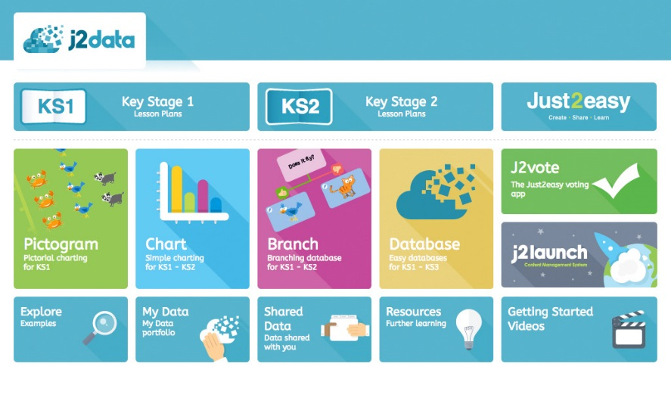

As you may be aware, we are in the process of creating and developing work for your child(ren) to complete remotely. Below is a list of activities we would like your child(ren) to complete over the next week.
They can be completed online using google classroom, google drive, seesaw, Hwb or paper based and a photograph sent.
Please may work be completed, at the latest, by 3pm, Thursday, 26th 2020.
Below, are activities we would like you to complete everyday if possible.
Read for 10 mins everyday using Giglets.
Practice your spellings.
Practice your times tables for 10 minutes everyday (2,3,4,5,6,8,10) (online activities such as top marks-hit the button; you tube songs, Seesaw activities, writing them out.

We have included the following project which can be completed over the course of 4 weeks.
Project work
Design a Roman themed maths game and write a set of instructions for it.

We would like to see photographs or videos of your game being played. These can be sent via Seesaw.
Finally, we would like to take this opportunity to say thank you to you for your support and understanding during this time.
Although we have set this work to be completed, we are mindful that this is a difficult time for everyone and that your family’s safety and wellbeing are paramount.
Please contact us if you need anything at all and we will do all we can to help and support you during this difficult time.
Stay safe,
Kind regards
Miss Harris and Mrs Roden-Sharpe

Week 1
Literacy, Language and Communication
 | Task 1 | Write a piece of writing to persuade me to give you 50 house points. (Google classroom activity)
 | Task 2 | Retell a story using the SeeSaw app. You could, type or record the story.
 | Task 3 | Write a set of instructions for how to catch the wolf from Little Red Riding Hood. (Parents the success criteria is at the end of this document). (Google classroom activity)

Mathematics
 | Task 1 | SeeSaw online activity- subtraction with renaming.
 | Task 2 | Mentimeter Pets questionnaire (join presentation code 84 46 69)
 | Task 3 | Reasoning paper 2017, for year 3 or year 4, available from school website on class page, national tests or https://www.coedybrainprimaryschool.co.uk/national-tests-1/

ICT/DCF
 | Task 1 | Log into HWB and go to j2easy, click on j2Data, click on database. Create a database about some of the famous Roman Emperors using the fact sheet. You will need fields for Name, Born, Death, Reign began, Reign ended and In office (the amount of time they were in charge). Data sent separately and at the end of this planning.
 | Task 2 | Using mentimeter, create a word cloud about the Romans (join presentation code 48 78 19)

Database HWB task
Log into HWB and go to j2easy, click on j2Data, click on database.
Create a database about some of the famous Roman Emperors using the data below. You will need fields for Name, Born, Death, Reign began, Reign ended and In office (the amount of time they were in charge).

Name | Birth | Death | Age when died | Reign started | Reign ended | Time in office
Augustus | 63 BC | 14 AD | 74 yrs | 27 BC | 14 AD | 40 years
Nero | 37 AD | AD | 30 yrs | 54 AD | 68 AD | 13 years
Julius Ceaser | 100 BC | 44 BC | 55 yrs | 49 BC | 59 BC | 10 years
Domitian | 51 AD | 96 AD | 44 yrs | 81 AD | 96 AD | 15 years
Hadrian | 76 AD | 138 AD | 62 yrs | 117 AD | 138 AD | 20 years
Tacitus | 200 AD | 276 AD | 76 yrs | 275 AD | 276 AD | 9 months
Constantine II | 316 AD | 340 AD | 24 yrs | 337 AD | 340 AD | 3 years

When you have entered this data into a database, I will send you a set of questions that you will need to use the database to answer.

Success Criteria for instructions:
Instructions
I accurately punctuated sentences with full stops and used capital letters for all proper nouns (names, places, days, months etc.).
A title and sub-headings,
An introduction,
A list of ‘things you will need’,
Step- by-step instructions
I used numbers or bullet points to make the order clear.
I used imperative or ‘bossy’ verbs
I used time openers

