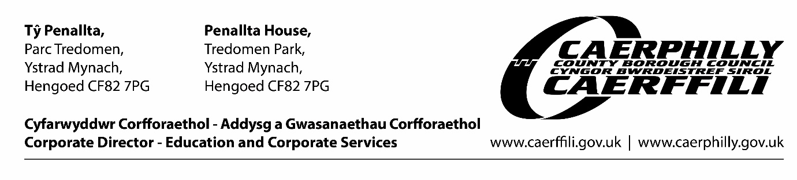
11th December, 2020.
Dear Parent / Carer,
I hope you are well.
You will be aware that there has been another announcement from Welsh Government following a clear recommendation from the Chief Medical Officer.
It relates only to secondary aged pupils and states that the last day of learning on site will be today, Friday 11th December.
There will be a distance learning model from next week apart from any days confirmed by the school as Inset days.
Pupils eligible for free school meals will receive them. Schools will also look to provide suitable support for their most vulnerable pupils.
The position for Trinity Fields, the Learning Centre and primary schools is that we have extended the distance learning offer from Thursday and Friday, to Wednesday, Thursday, Friday, the 16th, 17th and 18th due to a sharp increase in positive cases across the county borough, in children and adults, which has impacted on the ability of schools to keep classes open as they are encountering more difficulty in securing supply staff.
Your school will contact you to confirm arrangements for next week regarding any inset days that will be used.
I completely understand how difficult this is for you to manage. However, schools can only be open to pupils on site if they can be managed safely, with adequate staffing levels.
Thank you for your continued support and understanding in these uncertain times.
I sincerely hope that you have a safe family Christmas. I know that we will all be conscious of those in our communities that have been affected personally by this virus.

I will write to you before the beginning of the new school term to advise you of any arrangements.
Merry Christmas.
Keri

Keri Cole, Chief Education Officer, Caerphilly County Borough Council

